**A Web-Based Project**

**Online Course Platform**

**“A Mini Project Report”**

**“BACHELOR OF COMPUER APPLICATION”**

Submitted To -

**JEEVANDEEP MAHAVIDHALAY**

**Chandmari – Varanasi**



**Submitted by–**

**Sahil Atahar 13222407082**

**Under the Guidance of**

**Mr. Rajesh Sir**

**CERTIFICATE**

This is to certify that the project entitled, “**Online Course Platform”** presented by **Sahil Atahar** in partial fulfilment of the requirement for the Bachelor of Computer Applications at Jeevandeep Mahavidyalaya, Chandmari (UP), is a genuine work completed by the student under the guidance of **Mr. Rajesh Sir.** To the best of my knowledge, the issue embodied in the project has not been submitted to any other University/Institute for the award of any Degree.

Project Adviser

**Mr. Rajesh Sir.**

Assistant Professor

Date: __/__/____ ________________

Examiner

**DECLARATION**

I hereby declare that this project report titled “**Online Course Platform”** submitted in partial fulfilment of the degree of BCA, is a record of original work carried out by me under the supervision of **Mr. Rajesh Sir**, and has not formed the basis for the award of any other degree or diploma, in this or any other Institution or University. In accordance with ethical practices in reporting scientific information, due acknowledgements have been made wherever the findings of others have been cited.

Date: __/__/____ _______________________

Sahil Atahar (13222407082)

**Contents**

**Acknowledgement** 5

**Abstract** 6

**Introduction** 7

**Technical Implementation** 8

**Hardware and Software Requirements** 9

**Functionality and Features** 10

**Code** 11

**Output** 49

**Conclusion** 52

**Future Enhancements** 53

**About me** 54

# 

# **Acknowledgement**

We would like to express our heartfelt gratitude to Jeevandeep Mahavidyalaya, Chandmari, for providing us with the invaluable opportunity to embark on the challenging journey of developing the **“Online Course Platform”**. Our sincere thanks extend to our esteemed project guide, **Mr. Rajesh Sir**, for their unwavering support and guidance throughout this endeavor. We also wish to acknowledge the immense assistance rendered by the faculty and staff members of the BCA department, whose support and cooperation were indispensable. Lastly, we extend our sincere appreciation to the Head of the Department, BCA Department, for their encouragement and backing.

# 

# **Abstract**

The **“Online Course Platform”** is a revolutionary web-based tool aimed at offering comprehensive educational resources in an accessible and user-friendly manner. By leveraging modern web technologies, such as **HTML**, **CSS**, and **JavaScript**, our platform provides students with an immersive learning experience through curated video tutorials. With features like progress tracking and responsive design, the platform aims to enhance the accessibility and effectiveness of online education.

# 

# **Introduction**

The **“Online Course Platform”** marks a significant step forward in the realm of online education. In a world where digital learning is becoming increasingly prevalent, our platform seeks to bridge the gap between traditional classroom settings and virtual learning environments. By harnessing the power of technology, we aim to democratize education and empower learners of all backgrounds to pursue their academic goals.

# **Technical Implementation**

The development of the **“Online Course Platform”** involves the utilization of various web technologies, including HTML, CSS, and JavaScript. These languages are employed to create the platform's user interface and implement its functionality. Additionally, JSON is used for data storage and retrieval, while external libraries like Font Awesome and Swiper enhance the platform's design and user experience.

**Skills: -**

1. HTML, CSS, and JavaScript
2. JSON
3. External libraries

# 

# **Hardware and Software Requirements**

To access the **“Online Course Platform”**, users require basic components:

1. Computer system with keyboard, mouse, monitor, and adequate processing capabilities.
2. Compatibility with modern web browsers (e.g., Google Chrome, Mozilla Firefox).
3. Accessible across desktops, laptops, tablets, and smartphones.

# **Functionality and Features**

The **"Online Course Platform"** provides numerous features to enhance the learning experience.

1. Curated video tutorials covering diverse subjects.
2. Progress tracking tools for monitoring academic journey.
3. Dark mode for reduced eye strain.
4. Proper attribution to content creators.

# 

# **Code**

**Folder Structure: -**

|  |
| --- |
| ├──css/  │  ├── course.css  │  ├── index.css  │  └── scrollbar.css  ├──data/  │  └── data.json  ├──dialog/  │  ├── index.js  │  └── style.css  ├──images/  │  └── ...  ├──js/  │  ├── course.js  │  └── index.js  ├──index.html  ├──course.html  ├──favicon.ico  ├──LICENSE  └──README.md |

**css/course.css**

@import url("https://fonts.googleapis.com/css2?family=Poppins:wght@400;500&display=swap");

:root {

    --clr-primary: #2a2a2a;

    --clr-secondary: #ffffff;

    --clr-accent: #6554c0;

    --clr-container: rgb(221, 221, 221);

    --sb-thumb-color: #a8a8a8;

}

.dark-theme {

    --clr-primary: #ffffff;

    --clr-secondary: #161a1d;

    --clr-container: #21272c;

    --sb-thumb-color: #ffffff;

}

html {

    scroll-behavior: smooth;

    scroll-padding-top: 2rem;

}

* {

    padding: 0;

    margin: 0;

    box-sizing: border-box;

    font-family: "Poppins", sans-serif;

}

body {

    background-color: var(--clr-secondary);

    transition: all 0.2s;

    -webkit-transition: all 0.2s;

    -moz-transition: all 0.2s;

    -ms-transition: all 0.2s;

    -o-transition: all 0.2s;

    -webkit-user-select: none;

    -moz-user-select: -moz-none;

    -ms-user-select: none;

    user-select: none;

    max-height: 100vh;

    overflow: hidden;

    display: flex;

}

.sidebar {

    width: min(80vw, 500px);

    max-height: 100vh;

    min-height: 100dvh;

    display: flex;

    flex-direction: column;

    transition: all 0.3s;

    -webkit-transition: all 0.3s;

    -moz-transition: all 0.3s;

    -ms-transition: all 0.3s;

    -o-transition: all 0.3s;

    overflow-y: auto;

    background-color: var(--clr-secondary);

    overflow-x: hidden;

    border-right: 1px solid var(--clr-accent);

    /* For hiding sidebar */

    flex: 0;

    padding: 0;

    transform: translateX(-100%);

}

.sidebar.show {

    padding: 0 1rem;

    flex: 0.25;

    transform: translateX(0);

}

#close__sidebar__btn {

    width: 40px;

    aspect-ratio: 1;

    position: absolute;

    top: 1.3rem;

    right: 1rem;

    font-size: 2rem;

    display: flex;

    justify-content: center;

    align-items: center;

    color: var(--clr-accent);

    display: none;

}

.back__option {

    width: 100%;

    display: flex;

    align-items: center;

    gap: 1rem;

    padding: 1rem;

    color: var(--clr-accent);

    font-weight: bold;

    padding-top: 2rem;

    cursor: pointer;

}

.back__option .icon {

    font-size: 1.1rem;

}

.progress__block {

    padding: 1rem;

}

.progress__bar {

    height: 12px;

    box-shadow: 0px 0px 2px var(--clr-accent);

    border-radius: 1rem;

    -webkit-border-radius: 1rem;

    -moz-border-radius: 1rem;

    -ms-border-radius: 1rem;

    -o-border-radius: 1rem;

}

.progress__value {

    width: 0%;

    height: 100%;

    border-radius: 1rem;

    background-color: var(--clr-accent);

    -webkit-border-radius: 1rem;

    -moz-border-radius: 1rem;

    -ms-border-radius: 1rem;

    -o-border-radius: 1rem;

}

.progress__text {

    padding-top: 0.5rem;

    text-align: center;

    color: var(--clr-accent);

}

.topic__list {

    width: 100%;

    display: flex;

    flex-direction: column;

    gap: 1rem;

    margin-bottom: 1rem;

}

.list__item {

    display: flex;

    flex-direction: column;

    gap: 0.3rem;

    padding: 0.8rem;

    border-radius: 0.3rem;

    -webkit-border-radius: 0.3rem;

    -moz-border-radius: 0.3rem;

    -ms-border-radius: 0.3rem;

    -o-border-radius: 0.3rem;

    background-color: var(--clr-container);

    color: var(--clr-primary);

    padding-left: 1rem;

    cursor: pointer;

}

.list__item .title {

    text-overflow: ellipsis;

    overflow: hidden;

    display: -webkit-box;

    line-clamp: 1;

    -webkit-line-clamp: 1;

    -webkit-box-orient: vertical;

}

.list__item a {

    font-size: 1rem;

    color: var(--clr-secondary);

    overflow: hidden;

    display: -webkit-box;

    line-clamp: 1;

    -webkit-line-clamp: 1;

    -webkit-box-orient: vertical;

    font-weight: bold;

}

.channel,

.language {

    font-size: 0.8rem;

}

.body {

    width: 100%;

    min-height: 100vh;

    flex-direction: column;

    position: relative;

    transition: all 0.3s;

    -webkit-transition: all 0.3s;

    -moz-transition: all 0.3s;

    -ms-transition: all 0.3s;

    -o-transition: all 0.3s;

    background-color: var(--clr-secondary);

    flex: 1;

    overflow-y: auto;

}

.body.flex-0-75 {

    flex: 0.75;

}

.body__header {

    height: 60px;

    width: 100%;

    color: var(--clr-accent);

    background-color: var(--clr-secondary);

    display: flex;

    align-items: center;

    padding: 0 1.5rem;

    gap: 1rem;

    overflow-x: auto;

}

#toggle__navbar__btn {

    background-color: transparent;

    color: inherit;

    border: none;

    outline: none;

    font-size: 1.4rem;

    cursor: pointer;

}

.navbar__title {

    padding-left: 2rem;

}

.video__section {

    width: 80%;

    color: var(--clr-primary);

    margin: auto;

    margin-bottom: 2rem;

}

.error__text:not(:empty) {

    text-align: center;

    color: var(--clr-accent);

}

.video {

    width: 100%;

    max-width: 100%;

    max-height: 80vh;

    aspect-ratio: 16 / 9;

    margin: auto;

}

.video__title {

    margin-top: 1rem;

}

.video__description {

    margin-top: 0.5rem;

}

.options {

    width: 100%;

    padding-top: 2rem;

    display: flex;

    gap: 1rem;

    justify-content: space-between;

}

#prev__btn,

#next__btn {

    width: 150px;

    padding: 0.5rem;

    border: none;

    outline: none;

    font-size: 1rem;

    background-color: var(--clr-accent);

    color: #ffffff;

    border-radius: 0.3rem;

}

@media screen and (max-width: 768px) {

    #close__sidebar__btn {

        display: block;

    }

    .navbar__title {

        padding-left: 0.5rem;

        font-size: 1.5rem;

    }

    .sidebar {

        position: absolute;

        z-index: 2;

        top: 60px;

        min-height: 100vh;

    }

    .body__header {

        padding: 0rem 1rem;

    }

    .video__section {

        width: 90%;

        aspect-ratio: auto;

    }

    #prev__btn,

    #next__btn {

        width: 50%;

    }

}

**css/index.css**

@import url("https://fonts.googleapis.com/css2?family=Poppins:wght@400;500&display=swap");

:root {

    --clr-primary: #2a2a2a;

    --clr-secondary: #ffffff;

    --clr-accent: #6554c0;

    --clr-container: rgb(221, 221, 221);

    --sb-thumb-color: #a8a8a8;

}

.dark-theme {

    --clr-primary: #ffffff;

    --clr-secondary: #161a1d;

    --clr-container: #21272c;

    --sb-thumb-color: #ffffff;

}

html {

    scroll-behavior: smooth;

    scroll-padding-top: 2rem;

}

* {

    padding: 0;

    margin: 0;

    box-sizing: border-box;

    font-family: "Poppins", sans-serif;

}

body {

    background-color: var(--clr-secondary);

    transition: all 0.2s;

    -webkit-transition: all 0.2s;

    -moz-transition: all 0.2s;

    -ms-transition: all 0.2s;

    -o-transition: all 0.2s;

    -webkit-user-select: none;

    -moz-user-select: -moz-none;

    -ms-user-select: none;

    user-select: none;

}

/*  ========== Navbar CSS ========== */

.navbar {

    width: 100%;

    height: 50px;

    display: flex;

    justify-content: space-between;

    align-items: center;

    padding: 0 2rem;

    background-color: var(--clr-accent);

    position: sticky;

    top: 0;

    left: 0;

    z-index: 6;

    box-shadow: 0 2px 4px rgba(0, 0, 0, 0.1);

    position: relative;

}

.brand__name {

    color: #ffffff;

}

#toggle__navbar__btn {

    background-color: transparent;

    border: none;

    outline: none;

    color: #ffffff;

    font-size: 1.5rem;

    display: none;

}

.nav__list {

    width: 70%;

    display: flex;

    align-items: center;

    list-style: none;

    gap: 2.5rem;

    transition: height 1s ease;

    -webkit-transition: height 1s ease;

    -moz-transition: height 1s ease;

    -ms-transition: height 1s ease;

    -o-transition: height 1s ease;

}

.nav__list .list__item > * {

    text-decoration: none;

    color: #ffffff;

    font-weight: 500;

}

/*  ========== Swiper CSS ========== */

.swiper {

    width: 95%;

    max-width: 100%;

    aspect-ratio: 16 / 6;

    overflow: hidden;

    position: relative;

    display: flex;

    margin-top: 60px;

}

.swiper-slide {

    display: flex;

    justify-content: center;

    align-items: center;

}

.swiper-slide img {

    height: 100%;

    max-height: 100%;

    object-fit: contain;

}

.swiper-button-next,

.swiper-button-prev {

    color: var(--clr-primary);

    font-weight: bold;

    font-size: 1rem;

}

/*  ========== Trending Section CSS ========== */

.courses__section {

    width: 100%;

    display: flex;

    align-items: start;

    flex-direction: column;

    gap: 1.5rem;

    padding: 2rem;

}

.section__title {

    color: var(--clr-primary);

}

.courses__cards {

    width: 100%;

    display: flex;

    align-items: center;

    flex-wrap: wrap;

    gap: 1.5rem;

}

.courses__section .card {

    width: 250px;

    aspect-ratio: 1;

    background-color: var(--clr-container);

    border-radius: 0.5rem;

    -webkit-border-radius: 0.5rem;

    -moz-border-radius: 0.5rem;

    -ms-border-radius: 0.5rem;

    -o-border-radius: 0.5rem;

    transition: all 0.1s;

    -webkit-transition: all 0.1s;

    -moz-transition: all 0.1s;

    -ms-transition: all 0.1s;

    -o-transition: all 0.1s;

    display: flex;

    flex-direction: column;

    justify-content: space-evenly;

    align-items: center;

    position: relative;

    cursor: pointer;

}

.courses__section .card:hover {

    transform: scale(1.03);

    -webkit-transform: scale(1.03);

    -moz-transform: scale(1.03);

    -ms-transform: scale(1.03);

    -o-transform: scale(1.03);

}

.complete__mark:not(:empty) {

    position: absolute;

    top: 0rem;

    left: 0rem;

    background-color: var(--clr-accent);

    border-radius: 0.5rem 0 0.5rem 0;

    -webkit-border-radius: 0.5rem 0 0.5rem 0;

    -moz-border-radius: 0.5rem 0 0.5rem 0;

    -ms-border-radius: 0.5rem 0 0.5rem 0;

    -o-border-radius: 0.5rem 0 0.5rem 0;

    padding: 0.2rem;

    color: #ffffff;

}

.card__image {

    max-width: 100%;

    height: 70%;

    object-fit: contain;

}

.card__title {

    font-size: 1.3rem;

    font-weight: 500;

    color: var(--clr-primary);

}

@media screen and (max-width: 600px) {

    .swiper {

        width: 100%;

        height: 25vh;

        margin-top: 1rem;

    }

    .swiper-slide img {

        width: 100%;

        /* object-fit: cover; */

    }

    .navbar {

        padding: 0rem 1rem;

    }

    #toggle__navbar__btn {

        display: block;

    }

    .nav__list {

        width: 100%;

        position: absolute;

        flex-direction: column;

        top: 100%;

        left: 0;

        background-color: var(--clr-accent);

        gap: 1rem;

        padding-bottom: 1rem;

        overflow: hidden;

        transition: all 0.2s ease;

        -webkit-transition: all 0.2s ease;

        -moz-transition: all 0.2s ease;

        -ms-transition: all 0.2s ease;

        -o-transition: all 0.2s ease;

        transform: translateX(-100%);

    }

    .nav__list.show {

        transform: translateX(0);

    }

    .list__item {

        width: 100%;

    }

    .list__item > * {

        display: block;

        width: 100%;

        text-align: center;

    }

}

@media screen and (max-width: 768px) {

    .navbar {

        justify-content: space-between;

    }

    .nav__list {

        justify-content: end;

    }

    .courses__cards {

        justify-content: center;

    }

}

**css/scrollbar.css**

:root {

    --sb-track-color: #232e33;

    --sb-size: 7px;

}

*::-webkit-scrollbar {

    width: var(--sb-size);

}

*::-webkit-scrollbar-track {

    border-radius: 7px;

}

*::-webkit-scrollbar-thumb {

    background: var(--sb-thumb-color);

    border-radius: 7px;

}

@supports not selector(::-webkit-scrollbar) {

    body {

        scrollbar-color: var(--sb-thumb-color);

    }

}

**data/data.json**

[

    {

        "courseId": 1,

        "title": "HTML",

        "language": "Hindi & English",

        "poster": "html.png",

        "videos": [

            {

                "id": 1,

                "title": "HTML Tutorial For Beginners",

                "embed_url": "https://www.youtube.com/embed/BsDoLVMnmZs",

                "description": "Learn HTML in One Video: In this video, we will see how to create beautiful websites using Html. HTML is the language used for website design. This hindi course on html will teach you everything you need to learn about html tags, lists, tables, seo etc.",

                "language": "Hindi",

                "channel": "codewithharry"

            },

            ...

        ]

    },

    ...

]

**dialog/index.js**

const dialog = (function () {

  let element, dialog,okBtn;

  let animaArr = new Array(['fadeIn', 'fadeOut'], ['slideDown', 'slideUp']);

  let currAnimation = '';

  const getNeedelementent = () => {

    element = document.querySelector('.dialog-wrapper');

    dialog = element.querySelector('.dialog');

    okBtn = element.querySelector('.ok-btn');

  }

  const show = (options = {}) => {

    let {

      content = 'Please entry content',

      okText = 'ok',

      onOk = null,

      maskDisabled = false,

      animation = 1

    } = options;

    currAnimation = animation;

    const html = `

    <div class="dialog-wrapper fadeIn">

      <div class="dialog ${animaArr[currAnimation][0]}">

        <div class="icon"><i class="fa-solid fa-check"></i></div>

        <div class="content">${content}</div>

        <div class="buttons">

          <div class="btn ok-btn">${okText}</div>

        </div>

      </div>

    </div>

  `;

    document.body.innerHTML += html;

    getNeedelementent();

    bindEvent(onOk,maskDisabled);

    return element;

  }

  const bindEvent = (onOk, maskDisabled) => {

    okBtn?.addEventListener('click', e => {

      hide();

      onOk && onOk();

    })

    if (maskDisabled) {

      element.addEventListener('click', e => {

        let target = e?.target;

        if (/dialog-wrapper/.test(target.className)) {

          hide();

        }

      })

    }

  }

  const hide = () => {

    element.classList.add('fadeOut');

    dialog.classList.add(`${animaArr[currAnimation][1]}`);

    setTimeout(() => {

      element.remove();

    }, 200);

  }

  return {

    show,

    hide

  }

})();

window.dialog = dialog;

**dialog/style.css**

.dialog-wrapper {

    position: fixed;

    display: flex;

    justify-content: center;

    align-items: center;

    top: 0;

    left: 0;

    width: 100vw;

    height: 100vh;

    background-color: rgba(49, 49, 49, 0.5);

    color: #313131;

    font-size: 10px;

    -webkit-tap-highlight-color: transparent;

}

.dialog-wrapper.fadeIn {

    animation: fadeIn .2s ease;

}

.dialog-wrapper.fadeOut {

    animation: fadeOut .2s ease forwards;

}

.dialog-wrapper .dialog {

    position: relative;

    width: min(400px, 90vw);

    border-radius: .4em;

    background-color: #fff;

    box-sizing: border-box;

    overflow: hidden;

    box-shadow: 0 0 10px 1px rgba(0, 0, 0, 0.1);

    display: flex;

    flex-direction: column;

    justify-content: center;

}

.dialog-wrapper .dialog .icon {

    font-size: 3rem;

    width: max-content;

    aspect-ratio: 1;

    align-self: center;

    border-radius: 50%;

    -webkit-border-radius: 50%;

    -moz-border-radius: 50%;

    -ms-border-radius: 50%;

    -o-border-radius: 50%;

    background-color: #2ecc71;

    display: flex;

    justify-content: center;

    align-items: center;

    color: white;

    margin-top: 1rem;

    padding: 1rem;

}

.dialog-wrapper .dialog .btn {

    cursor: pointer;

}

.dialog-wrapper .dialog .btn:active {

    background-color: #f4f4f4;

}

.dialog-wrapper .dialog .close-btn {

    position: absolute;

    top: 0;

    right: 0;

    padding: 10px;

    font-size: 1.8em;

}

.dialog-wrapper .dialog .content {

    padding: 1rem;

    font-size: 1.6em;

    text-align: center;

}

.dialog-wrapper .dialog.slideDown {

    animation: slideDown .2s ease;

}

.dialog-wrapper .dialog.slideUp {

    animation: slideUp .2s ease forwards;

}

.dialog-wrapper .dialog .buttons {

    font-size: 1.6em;

    display: flex;

    flex-flow: row-reverse;

}

.dialog-wrapper .dialog .buttons .btn {

    flex: 1;

    padding: 15px;

    text-align: center;

    border-top: 1px solid #ebebeb;

}

@keyframes slideDown {

    from {

        transform: translateY(-3em);

    }

    to {

        transform: translateY(0);

    }

}

@keyframes slideUp {

    from {

        transform: translateY(0);

    }

    to {

        transform: translateY(-3em);

    }

}

@keyframes fadeIn {

    from {

        opacity: .5;

    }

    to {

        opacity: 1;

    }

}

@keyframes fadeOut {

    from {

        opacity: 1;

    }

    to {

        opacity: 0;

    }

}

**js/course.js**

const toggleNavbarBtn = document.querySelector("#toggle__navbar__btn")

const sidebar = document.querySelector(".sidebar")

const sidebarList = document.querySelector(".topic__list")

const progressValue = document.querySelector(".progress__value")

const progressText = document.querySelector(".progress__text")

const homeOption = document.querySelector(".back__option")

const body = document.querySelector(".body")

const navTitle = document.querySelector(".navbar__title")

const iframe = document.querySelector("#iframe")

const videoTitle = document.querySelector(".video__title")

const videoDesc = document.querySelector(".video__description")

const nextBtn = document.getElementById("next__btn")

const prevBtn = document.getElementById("prev__btn")

const searchParams = new URLSearchParams(window.location.search)

// Changing theme

let theme = localStorage.getItem("theme")

if (theme === "dark") {

    document.body.classList.add("dark-theme")

}

// Function to read JSON file asynchronously

const readJSONFile = async () => {

    let data

    try {

        let urlArray = window.location.href.split("/")

        urlArray.pop()

        urlArray.push("data", "data.json")

        let jsonUrl = urlArray.join("/")

        data = await fetch(jsonUrl).then((respond) => respond.json())

    } catch {

        console.log("JSON file reading error")

    }

    return data

}

// Retrieve the current course ID from local storage

const currentCourseId = searchParams.get("id")

let data = await readJSONFile()

let cCourse = data.filter((course) => course.courseId == currentCourseId)[0]

// Initialize variables for course management

let index = 0

let cVideoData = cCourse.videos[index]

let progress = 0

// Function to change the video based on the given index

const changeVideo = (index) => {

    cVideoData = cCourse.videos[index]

    // Update the video player and related information

    iframe.src = cVideoData.embed_url

    videoTitle.textContent = cVideoData.title

    videoDesc.textContent = cVideoData.description

    // Update the text of the next button based on the index

    if (index == cCourse.videos.length - 1) {

        nextBtn.textContent = "Finish"

    } else {

        nextBtn.textContent = "Next"

    }

}

// Putting Course nav title

navTitle.textContent = cCourse.title

// Putting first video url

changeVideo(index)

// Adjusting main body content height

if (window.innerWidth > 768) {

    body.classList.add("flex-0-75")

}

// Toggle Navbar when toggleNavbarBtn is clicked

toggleNavbarBtn.addEventListener("click", () => {

    const isMobile = window.innerWidth < 768

    sidebar.classList.toggle("show")

    if (!isMobile) {

        body.classList.toggle("flex-0-75")

    }

})

// Redirect to the home page when homeOption is clicked

homeOption.addEventListener("click", () => {

    let urlArray = window.location.href.split("/")

    urlArray.pop()

    urlArray.push("index.html")

    let newUrl = urlArray.join("/")

    window.location.href = newUrl

})

// Adding Sidebar topics

sidebarList.innerHTML = ""

cCourse.videos.forEach((video, index) => {

    sidebarList.innerHTML += `<li class="list__item" id="list__item${index}">

                <h4 class="title">${video.title}</h4>

                <p class="language">Language : ${video.language}</p>

            </li>`

})

// Handling click on sidebar topics

document.querySelectorAll(`.list__item`).forEach((item, itemIndex) =>

    item.addEventListener("click", (e) => {

        index = itemIndex

        changeVideo(index)

    })

)

function btnClick(e) {

    // Check if the button clicked has an id of 'next__btn'

    if (e.target.id === "next__btn") {

        // Increment progress if the current index is within the video length

        if (index < cCourse.videos.length - 1) {

            progress++

            let percent

            if (progress > cCourse.videos.length) {

                percent = 100

            } else {

                percent = (progress / cCourse.videos.length) * 100

            }

            progressValue.style.width = `${percent}%`

            progressText.textContent = `${Math.floor(percent)}% Completed`

        }

        // Check if there are more videos to navigate to

        if (index < cCourse.videos.length - 1) {

            index++

        } else {

            // Check if the progress is 50% or more

            if ((progress / cCourse.videos.length) * 100 >= 50) {

                let userData = JSON.parse(localStorage.getItem("userData")) || {

                    completedCourses: [],

                }

                userData.completedCourses.push(cCourse.title)

                localStorage.setItem("userData", JSON.stringify(userData))

                // Display a dialog indicating completion and redirect to home

                window.dialog.show({

                    content: `You have completed the ${cCourse.title} Course`,

                    okText: "Go to Home",

                    onOk: () => {

                        let urlArray = window.location.href.split("/")

                        urlArray.pop()

                        urlArray.push("index.html")

                        let newUrl = urlArray.join("/")

                        window.location.href = newUrl

                    },

                })

            } else {

                // Display an error message if progress is less than 50%

                document.querySelector(".error__text").textContent =

                    "You should complete at least 50% of the Course"

                return

            }

        }

    } else {

        // Check if there are previous videos to navigate to

        if (index > 0) {

            index--

        } else {

            return

        }

    }

    // Update the video based on the current index

    changeVideo(index)

}

// setting next btn click

nextBtn.addEventListener("click", (e) => btnClick(e))

prevBtn.addEventListener("click", (e) => btnClick(e))

// Handling resizing

window.addEventListener("resize", () => {

    const isMobile = window.innerWidth < 768

    if (isMobile) {

        sidebar.classList.remove("show")

        body.classList.remove("flex-0-75")

    } else {

        sidebar.classList.add("show")

        body.classList.add("flex-0-75")

    }

})

**js/index.js**

const trendingSection = document.getElementById("trending__cards")

const allCoursesSection = document.getElementById("all__courses__cards")

const toggleNavbarBtn = document.getElementById("toggle__navbar__btn")

const toggleThemeBtn = document.getElementById("theme__toggle__btn")

// Variables

let data

let userData = JSON.parse(localStorage.getItem("userData"))

let isDarkTheme = false

// Changing theme

let theme = localStorage.getItem("theme")

if (theme === "dark") {

    isDarkTheme = true

    document.body.classList.add("dark-theme")

    toggleThemeBtn.innerHTML = '<i class="fa-regular fa-sun"></i>'

} else {

    toggleThemeBtn.innerHTML = '<i class="fa-regular fa-moon"></i>'

    localStorage.setItem("theme", "light")

}

// Reading JSON File

const readJSONFile = async () => {

    let data

    try {

        let urlArray = window.location.href.split("/")

        urlArray.pop()

        urlArray.push("data", "data.json")

        let jsonUrl = urlArray.join("/")

        data = await fetch(jsonUrl).then((respond) => respond.json())

    } catch {

        console.log("JSON file reading error")

    }

    return data

}

data = await readJSONFile()

// Toggle Navbar

toggleNavbarBtn.addEventListener("click", () => {

    document.querySelector(".nav__list").classList.toggle("show")

})

// Adding trending corses

data.slice(1, 3).forEach((course) => {

    trendingSection.innerHTML += `<div class="card ${course.title}__Card">

                <div class="complete__mark">${

                    userData != null &&

                    userData?.completedCourses?.includes(course.title)

                        ? "Completed"

                        : ""

                }</div>

                <img src="./images/${course.poster}" alt="${

        course.title

    } image" class="card__image">

                <p class="card__title">${course.title}</p>

            </div>`

})

// Adding All courses

data.forEach((course) => {

    allCoursesSection.innerHTML += `<div class="card ${course.title}__Card">

                <div class="complete__mark">${

                    userData != null &&

                    userData?.completedCourses?.includes(course.title)

                        ? "Completed"

                        : ""

                }</div>

                <img src="./images/${course.poster}" alt="${

        course.title

    } image" class="card__image">

                <p class="card__title">${course.title}</p>

            </div>`

})

data.forEach((course) => {

    let cards = document.querySelectorAll(`.${course.title}__Card`)

    cards.forEach((card) => {

        card.addEventListener("click", () => {

            localStorage.setItem("currentCourseId", course.courseId)

            window.location.href = `/course.html?id=${course.courseId}`

        })

    })

})

const swiper = new Swiper(".swiper", {

    // Optional parameters

    loop: true,

    pagination: {

        el: ".swiper-pagination",

    },

    // Autoplay

    autoplay: {

        delay: 5000,

    },

    navigation: {

        nextEl: ".swiper-button-next",

        prevEl: ".swiper-button-prev",

    },

})

// Toggle Theme

toggleThemeBtn.addEventListener("click", (e) => {

    if (isDarkTheme) {

        toggleThemeBtn.innerHTML = '<i class="fa-regular fa-moon"></i>'

    } else {

        toggleThemeBtn.innerHTML = '<i class="fa-regular fa-sun"></i>'

    }

    isDarkTheme = !isDarkTheme

    localStorage.setItem("theme", isDarkTheme ? "dark" : "light")

    document.body.classList.toggle("dark-theme")

})

**course.html**

<!DOCTYPE html>

<html lang="en">

    <head>

        <meta charset="UTF-8" />

        <meta http-equiv="X-UA-Compatible" content="IE=edge" />

        <meta name="viewport" content="width=device-width, initial-scale=1.0" />

        <link

            rel="stylesheet"

            href="https://cdnjs.cloudflare.com/ajax/libs/font-awesome/6.4.0/css/all.min.css"

            integrity="sha512-iecdLmaskl7CVkqkXNQ/ZH/XLlvWZOJyj7Yy7tcenmpD1ypASozpmT/E0iPtmFIB46ZmdtAc9eNBvH0H/ZpiBw=="

            crossorigin="anonymous"

            referrerpolicy="no-referrer"

        />

        <link

            rel="stylesheet"

            href="https://cdn.jsdelivr.net/npm/swiper@9/swiper-bundle.min.css"

        />

        <link rel="shortcut icon" href="favicon.png" type="image/x-icon" />

        <link rel="icon" href="favicon.png" type="image/x-icon" />

        <title>Capstone</title>

        <link rel="stylesheet" href="./dialog/style.css" />

        <link rel="stylesheet" href="./css/course.css" />

        <link rel="stylesheet" href="./css/scrollbar.css" />

    </head>

    <body>

        <aside class="sidebar show">

            <div class="sidebar__header">

                <div class="back__option">

                    <i class="fa-solid fa-arrow-left icon"></i>

                    <p>Go to homepage</p>

                </div>

                <div class="progress__block">

                    <div class="progress__bar">

                        <div class="progress__value"></div>

                    </div>

                    <p class="progress__text">0% Completed</p>

                </div>

            </div>

            <ul class="topic__list"></ul>

        </aside>

        <div class="body">

            <header class="body__header">

                <button id="toggle__navbar__btn">

                    <i class="fa-solid fa-bars"></i>

                </button>

                <h2 class="navbar__title"></h2>

            </header>

            <section class="video__section">

                <p class="error__text"></p>

                <iframe

                    src=""

                    title="Capstone video player"

                    frameborder="0"

                    allowfullscreen

                    class="video"

                    id="iframe"

                ></iframe>

                <h1 class="video__title"></h1>

                <p class="video__description"></p>

                <div class="options">

                    <button id="prev__btn">Previous</button>

                    <button id="next__btn">Next</button>

                </div>

            </section>

        </div>

        <script src="./dialog/index.js"></script>

        <script src="./js/course.js" type="module"></script>

    </body>

</html>

**index.html**

<!DOCTYPE html>

<html lang="en">

    <head>

        <meta charset="UTF-8" />

        <meta http-equiv="X-UA-Compatible" content="IE=edge" />

        <meta name="viewport" content="width=device-width, initial-scale=1.0" />

        <link

            rel="stylesheet"

            href="https://cdnjs.cloudflare.com/ajax/libs/font-awesome/6.4.0/css/all.min.css"

            integrity="sha512-iecdLmaskl7CVkqkXNQ/ZH/XLlvWZOJyj7Yy7tcenmpD1ypASozpmT/E0iPtmFIB46ZmdtAc9eNBvH0H/ZpiBw=="

            crossorigin="anonymous"

            referrerpolicy="no-referrer"

        />

        <link

            rel="stylesheet"

            href="https://cdn.jsdelivr.net/npm/swiper@9/swiper-bundle.min.css"

        />

        <link rel="shortcut icon" href="favicon.png" type="image/x-icon" />

        <link rel="icon" href="favicon.png" type="image/x-icon" />

        <title>Capstone</title>

        <link rel="stylesheet" href="./css/index.css" />

        <link rel="stylesheet" href="./css/scrollbar.css" />

        <script src="https://cdn.jsdelivr.net/npm/swiper@9/swiper-bundle.min.js"></script>

        <script src="https://cdn.jsdelivr.net/npm/sweetalert2@11"></script>

    </head>

    <body>

        <!-- Navbar -->

        <nav class="navbar">

            <h2 class="brand__name">Capstone</h2>

            <ul class="nav__list">

                <li class="list__item"><a href="index.html">Home</a></li>

                <li class="list__item">

                    <a href="#trending_courses">Courses</a>

                </li>

                <li class="list__item"><a href="#">About</a></li>

                <li class="list__item"><a href="#">Contact</a></li>

                <li class="list__item">

                    <div id="theme__toggle__btn">

                        <i class="fa-regular fa-moon"></i>

                    </div>

                </li>

            </ul>

            <button id="toggle__navbar__btn">

                <i class="fa-solid fa-bars"></i>

            </button>

        </nav>

        <!-- Slider main container -->

        <div class="swiper">

            <!-- Additional required wrapper -->

            <div class="swiper-wrapper">

                <!-- Slides -->

                <div class="swiper-slide">

                    <img src="./images/image1.jpg" alt="image 1" />

                </div>

                <div class="swiper-slide">

                    <img src="./images/image2.jpg" alt="image 2" />

                </div>

                <div class="swiper-slide">

                    <img src="./images/image3.jpg" alt="image 3" />

                </div>

                <div class="swiper-slide">

                    <img src="./images/image4.jpg" alt="image 4" />

                </div>

                <div class="swiper-slide">

                    <img src="./images/image5.jpg" alt="image 5" />

                </div>

            </div>

            <!-- If we need pagination -->

            <div class="swiper-pagination"></div>

            <!-- If we need navigation buttons -->

            <div class="swiper-button-prev"></div>

            <div class="swiper-button-next"></div>

        </div>

        <!-- Trending Courses Section -->

        <section class="courses__section" id="trending_courses">

            <h1 class="section__title">Trending Courses</h1>

            <div class="courses__cards" id="trending__cards"></div>

        </section>

        <!-- All Courses Section -->

        <section class="courses__section" id="all__courses">

            <h1 class="section__title">All Courses</h1>

            <div class="courses__cards" id="all__courses__cards"></div>

        </section>

        <script src="./js/index.js" type="module"></script>

    </body>

</html>

The source code for the **"Online Course Platform"** project is available for reference. You can access the repository containing the project's code on GitHub at the following URL:

GitHub URL: <https://github.com/sahilatahar/Capstone>

# **Output**

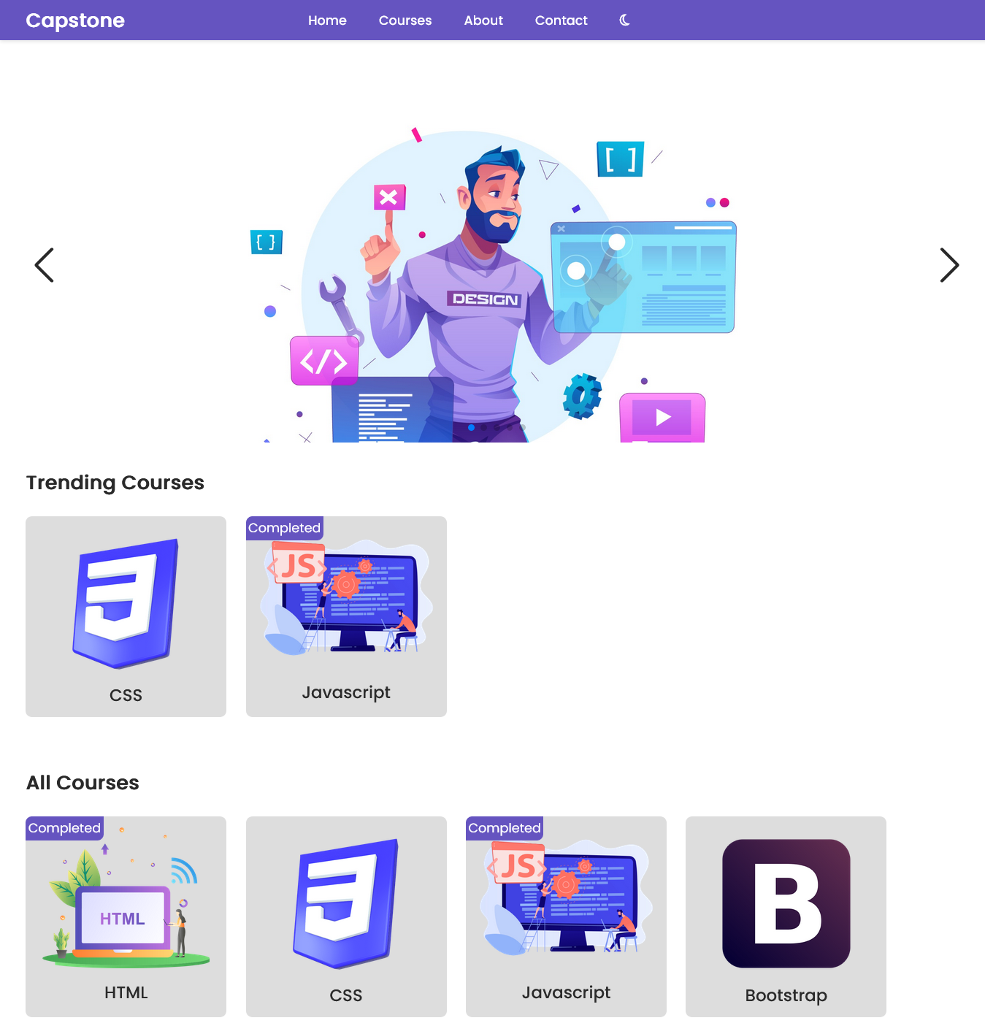

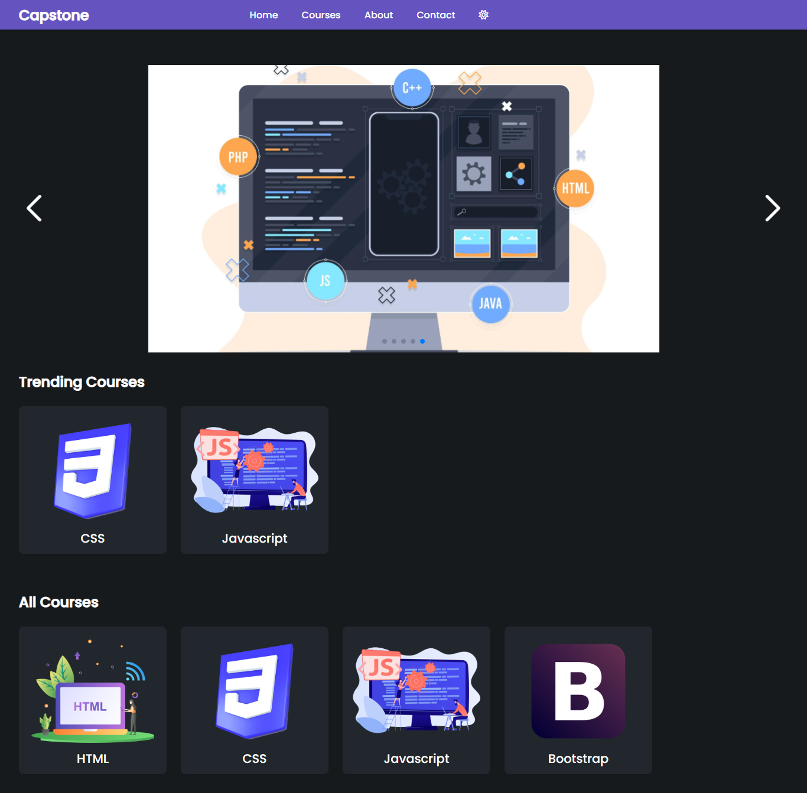

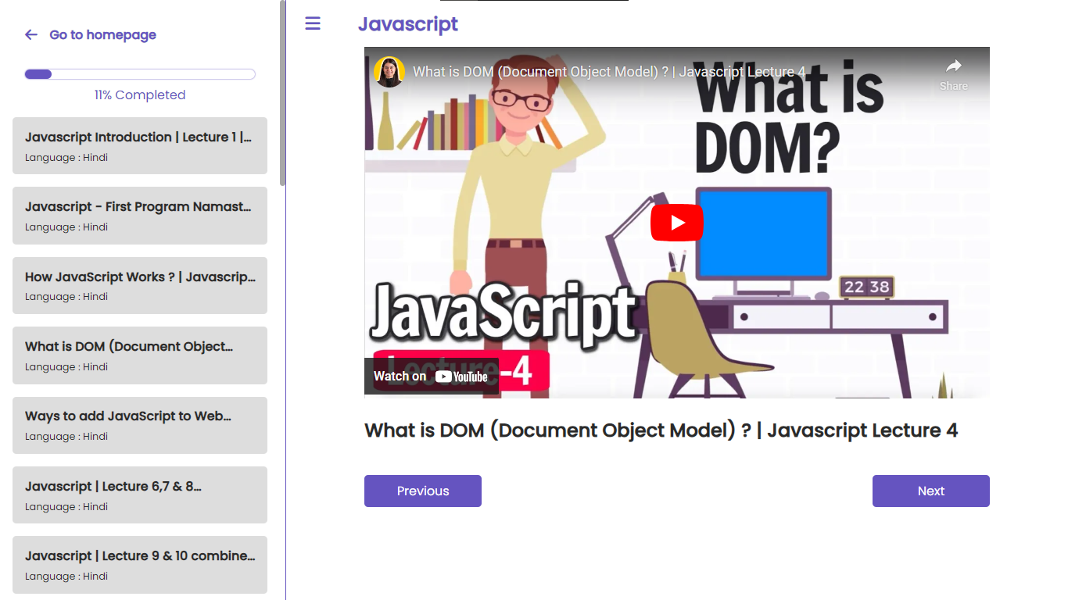

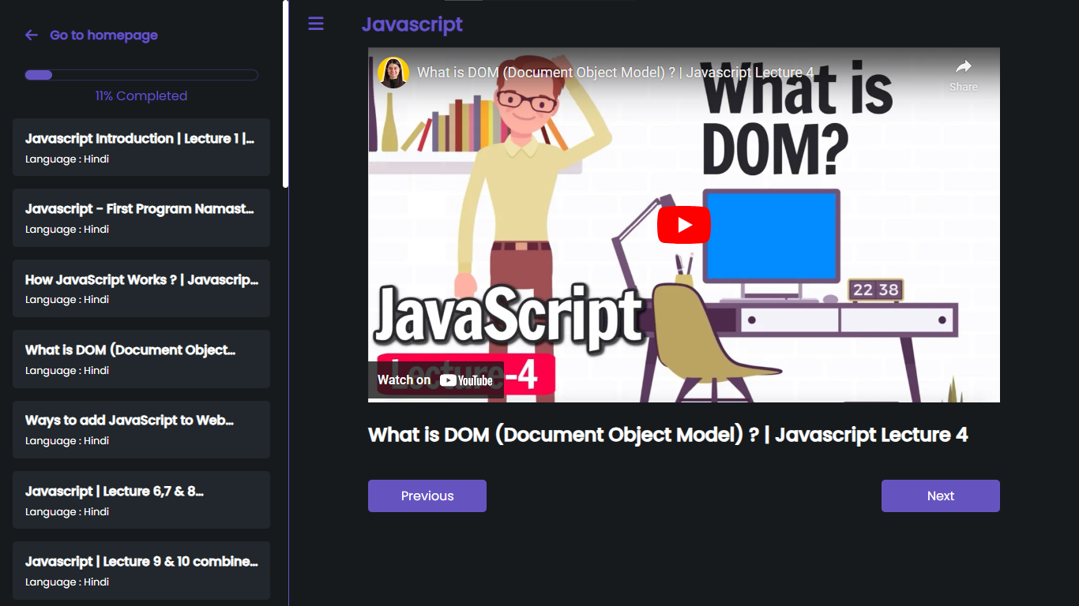

# 

# **Conclusion**

In conclusion, the development of the **“Online Course Platform”** has been a testament to the power of collaboration and innovation. Despite facing various challenges along the way, our team has successfully delivered a robust and user-friendly platform that has the potential to revolutionize the field of online education. Moving forward, we remain committed to enhancing the platform's features and expanding its reach to serve an even wider audience.

# 

# **Future Enhancements**

While the current version of the **"Online Course Platform"** does not include plans for future enhancements, its existing features and functionality are designed to meet the needs of users without requiring additional updates. The platform is intended to provide a stable and reliable environment for accessing educational resources, with no plans for further development or modifications.

# **About me**

As a web developer, I am committed to continuously learning and expanding my skill set. Currently, I am focused on mastering NextJS and TypeScript, aiming to leverage these technologies to create more efficient and scalable web applications. I am also actively seeking opportunities to collaborate on open-source projects, where I can contribute to the development community and gain valuable experience.

**Socials:**

Gmail: [sahilatahar@gmail.com](mailto:sahilatahar@gmail.com)

GitHub: <https://github.com/sahilatahar>

LinkedIn: <https://www.linkedin.com/in/sahilatahar>

Link Tree: <https://linktr.ee/sahilatahar>

**Tech Stack:**

**Frontend:** HTML, CSS, SASS, JavaScript, React, React Router, Tailwind CSS, Redux

**Backend**: NodeJS, ExpressJS, JWT

**Database**: MongoDB, Firebase

**Tools**: Git, GitHub, VS Code, Prettier

**Deployment**: Netlify, GitHub Pages, Vercel

**Programming Languages**: C

**Others**: Markdown, Firefox, Chrome, Windows

**Top Repositories:**

Code-Sync: <https://github.com/sahilatahar/Code-Sync>

Real-Notes: <https://github.com/sahilatahar/Real-Notes>

Markdown2PDF: <https://github.com/sahilatahar/markdown2pdf>